Interrogative Determiners

❓ What Are Interrogatives (Types of Determiners)?
# Source: AI Source: Provided by: [Data Path: Persons Table -> ID Column: 1, Name_En Column: Motasem Essam] -> From: [Chatgpt (GPT-4-turbo)] on [7/28/2025]
Interrogative determiners are used to ask questions and are always placed before a noun.
They help in asking about identity, quantity, or ownership of the noun.

✅ Common Interrogative Determiners:
# Source: AI Source: Provided by: [Data Path: Persons Table -> ID Column: 1, Name_En Column: Motasem Essam] -> From: [Chatgpt (GPT-4-turbo)] on [7/28/2025]
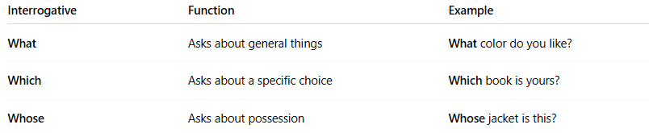
Interrogative | Function | Example
What | Asks about general things | What color do you like?
Which | Asks about a specific choice | Which book is yours?
Whose | Asks about possession | Whose jacket is this?

🧩 Notes:
# Source: AI Source: Provided by: [Data Path: Persons Table -> ID Column: 1, Name_En Column: Motasem Essam] -> From: [Chatgpt (GPT-4-turbo)] on [7/28/2025]
- These are not pronouns on their own — they must be followed by a noun.
  - ✅ Interrogative Determiner: What movie are you watching?
  - ❌ Interrogative Pronoun: What are you watching?

📌 Summary Table:
# Source: AI Source: Provided by: [Data Path: Persons Table -> ID Column: 1, Name_En Column: Motasem Essam] -> From: [Chatgpt (GPT-4-turbo)] on [7/28/2025]
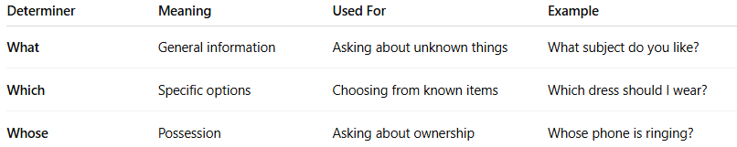
Determiner | Meaning | Used For | Example
What | General information | Asking about unknown things | What subject do you like?
Which | Specific options | Choosing from known items | Which dress should I wear?
Whose | Possession | Asking about ownership | Whose phone is ringing?

